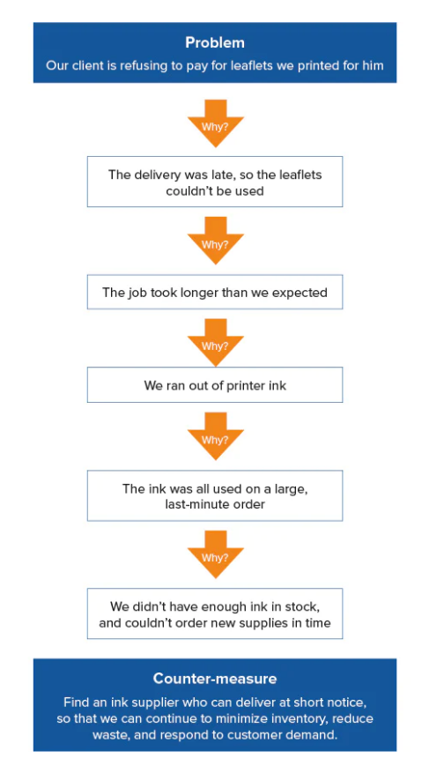
1.- Identify a problem which involves sustainability problem/circular economy and try to find the proper cause by implementing the 5 whys technique.
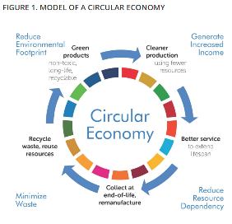
EXAMPLE:

